Rochdale Pioneer Award 2013
Nomination Form

NOMINEE
Full Name
Position/Title
Organisation
Gender |  | Nationality
Brief Biographical Note (maximum 100 words) - Please attach full Curriculum Vitae and photo

NOMINEES’ ACHIEVEMENTS (please attached any relevant documents illustrating these)
Benefit to the global co-operative movement
Innovation
Sustainability
Gender issues and concern for the community

NOMINATING ORGANISATION
Organisation name
Address
Tel |  | Fax
Email

SIGNATURES
NOMINATING ORGANISATION |  | NOMINEE CONTACT DETAILS
Signature |  | Full address
Name and title of signatory |  | Tel
Date |  | e-mail

This form has to be submitted duly filled and accompanied with required documents by September 4th, 2013 to the following address: election.committee@ica.coop.
Forms received after this date will not be considered.

Rochdale Pioneers Award
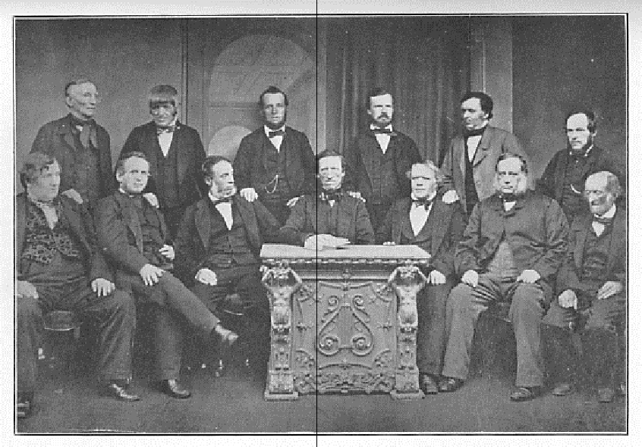

In 2000, the ICA Board established the Rochdale Pioneers Award.

The purpose of this Award is to recognise a person or, under special circumstances a

co-operative organisation, having contributed to innovative and financially sustainable co-operative activities that have significantly benefited their membership.

Rochdale Pioneers Award laureates:

2001 | 2003 |  |  | 2005
Dr. Verghese | Francisco Luis | Lloyd | Hans | Yehudah | Ian
Kurien | Jiménez Arcila | Wilkinson | Dahlberg | Paz | MacPherson
(India) | (Colombia) | (UK) | (Sweden) | (Israel) | (Canada)
 | 2007 |  | 2009 |  | 2011
Esther | Pr. Ungku A. | Francisco | Ivano | Lee | Pr. Florencio
Gicheru | Aziz | Ceballo Herrero | B arberini¹ | Jong-koo | Eguía Villaseñor
(Kenya) | (Malaysia) | (Spain) | (Italy) | (Korea) | (Mexico)
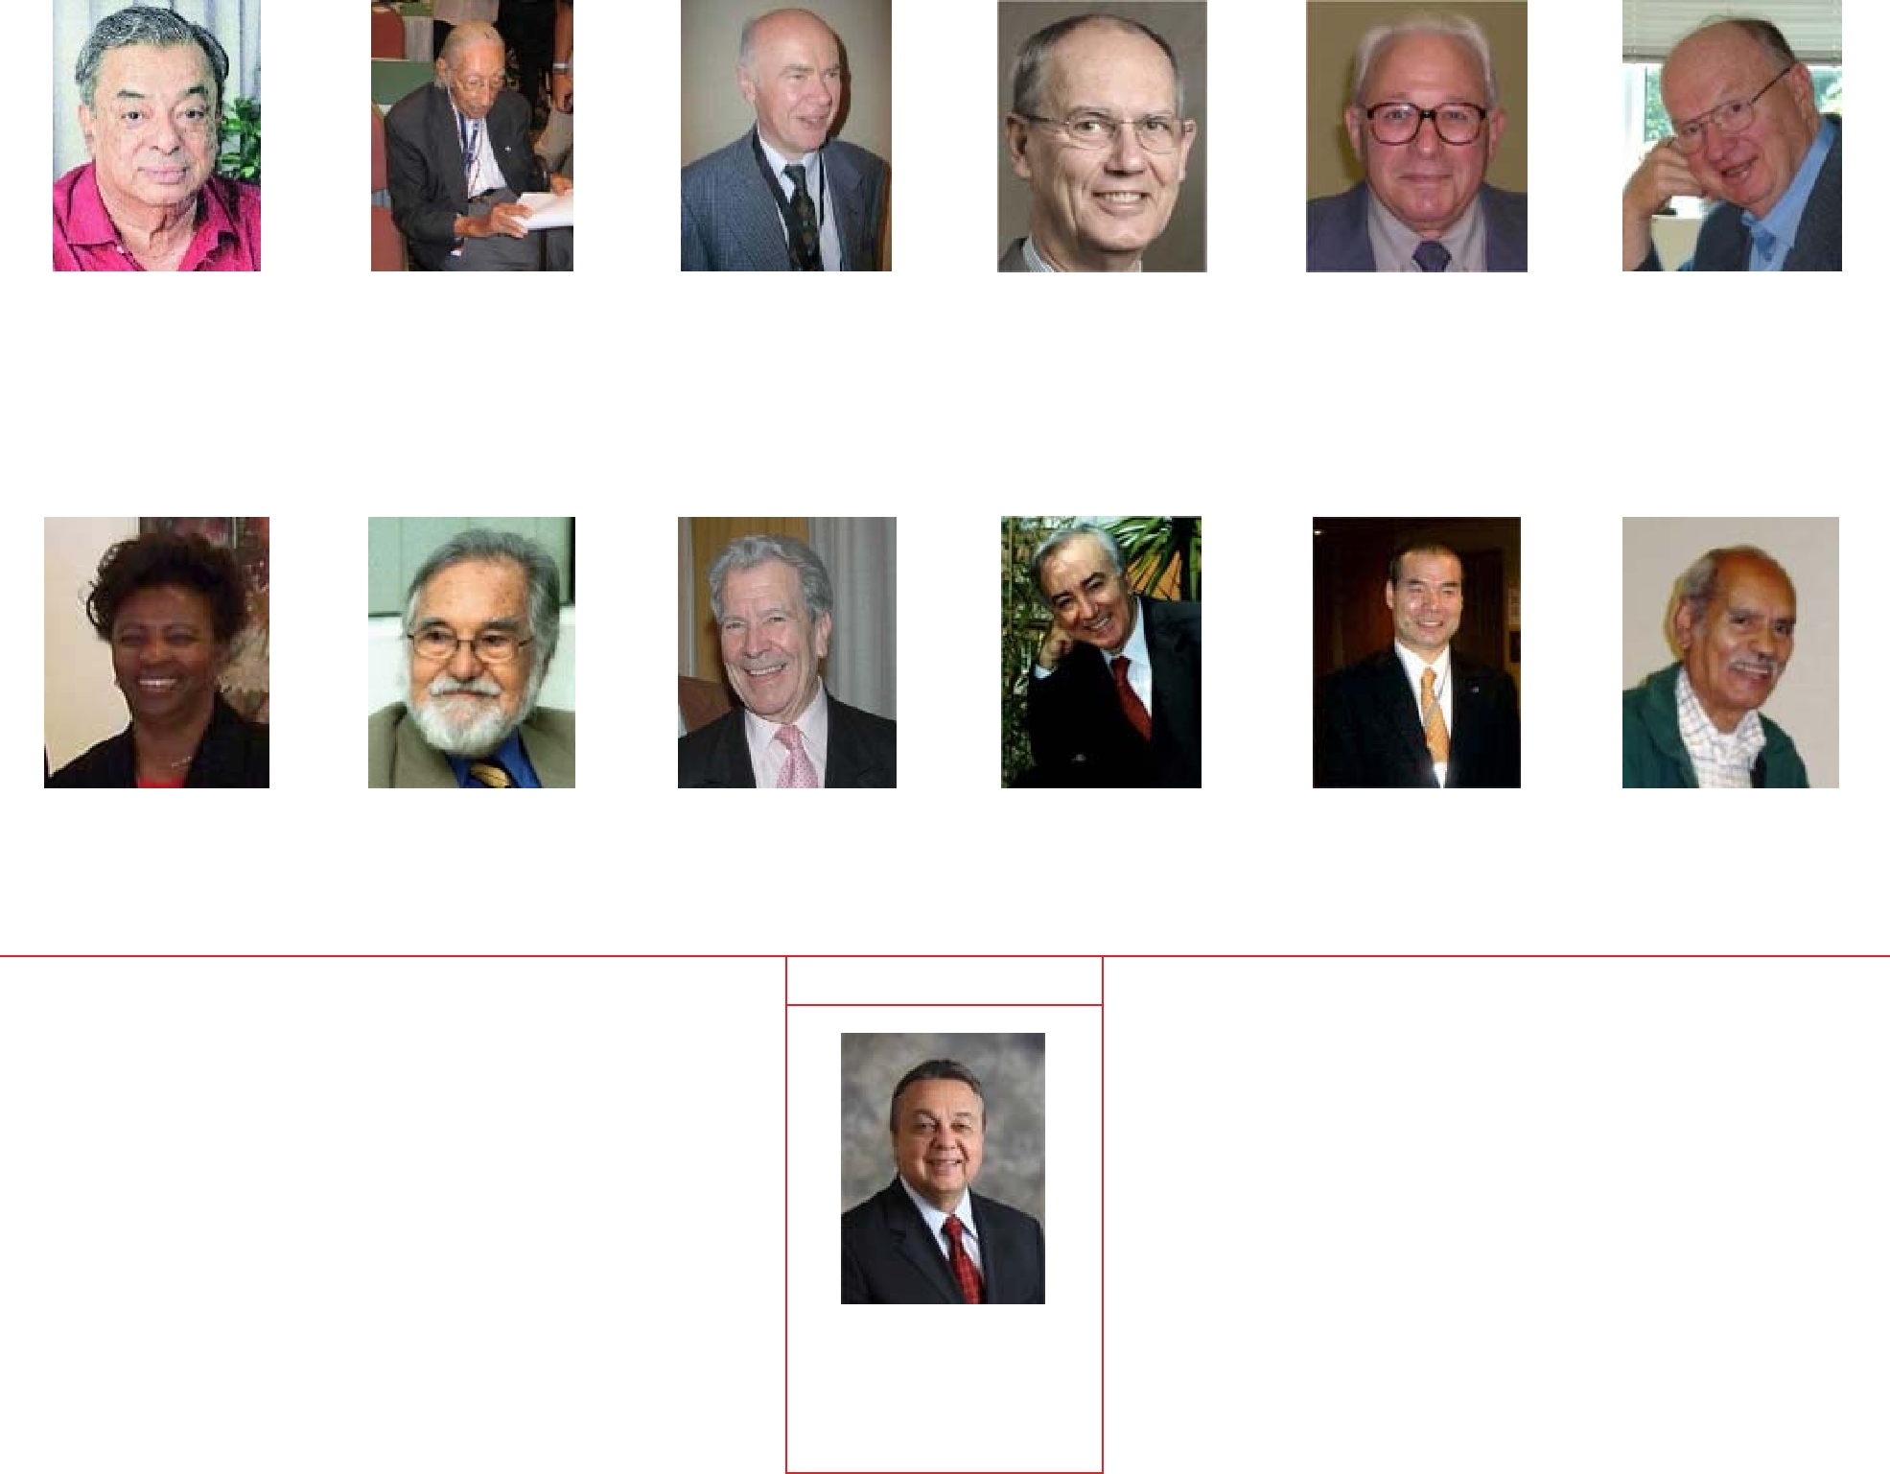
2012

 | H.E. Roberto
 | Rodrigues
 | (Brazil)
1: | The ICA Board has decided that the 2009 Rochdale Pioneer Award will be posthumously conferred to Ivano
 | Barberini for his life-long contribution and legacy to the world co-operative movement.

